Aryan Gupta
 Charlotte, NC → agupta40@uncc.edu  980-666-0648  theguptaempire.net/about-me
Aug 24, 2026
Dear Hiring Manager,
I am writing to apply for the ML Engineer, II position at Torc. I recently graduated from the University of North Carolina at Charlotte (UNCC) with a B.S. in Computer Engineering and am currently pursuing an M.S. in Computer Engineering. I expect to graduate in December of 2026. My previous job was at Wells Fargo as a Software Engineer. I am looking to move into the machine-learning field.
My senior design project was the UNCC’s NASA USLI (University Student Launch Initiative) competition. For this project, we designed a rocket that traveled 4000 ft into the atmosphere and deployed a drone (UAS) that would travel to a sample recovery area (SRA) to collect a 10 ml sample of simulated lunar ice and transport it away. My responsibilities included writing an application that will process the video taken from the rocket and locating the SRA site during its accent to apogee, writing embedded applications to control the servos and motors to deploy the UAS, and designing programs to autonomously control the flight of the UAS. I had to communicate my requirements to the Mechanical Engineers and work with the Electrical Engineers on the team to program and deploy the drone. We placed first place nationally in payload and second place nationally overall.
Currently, for my graduate thesis, I am designing a reinforcement learning model for a path-finding agent. Even though this thesis is a work in progress, I am confident that I will be able to complete it by the time I graduate. I have extensive experience with C++ and loved programming in it, however recently I have started to use more python in my projects as it's easier to write prototypes and get proof-of-concepts quicker. I regularly practice my programming ability using Leet Code and personal projects.
My position as an IT System Administrator II has provided me with the ability to network with various research faculty at my college. I have already worked with many of the faculty on research projects and helped them set up their computers and servers for their labs. Also, in my current position, I support many of the research Linux machines and servers for their work. Personally, I currently run over six hardware and VM-based machines running Linux, Windows, and FreeBSD in my ever-expanding home lab. Even though I live in an apartment that already has network infrastructure, I have sectioned off the network to accommodate my hobbies as a system administrator. I currently run Arch Linux as a daily driver for both my main desktop and laptop, both provisioned by Ansible. This work has allowed me to refine my troubleshooting, customer service, and Linux skills.
My previous position at Ensco Avionics and Wells Fargo has provided me with the ability to write industry standard code and test code to ensure all code is to the standard of the company and ensure minimal bugs and issues. I have learned to work with AI LLMs and with other people in an agile project management methodology to speed up our productivity
I’ve attached my resume, which further details my skills and education. I can offer references for any items upon request. I’m confident that my familiarity with TensorFlow, past rigorous embedded projects, and my substantial Linux skills will make me an asset at the Firmware Developer position and allow me to contribute to the team’s success. Thank you for your time and consideration of my application, and I look forward to hearing from you soon.
Sincerely,
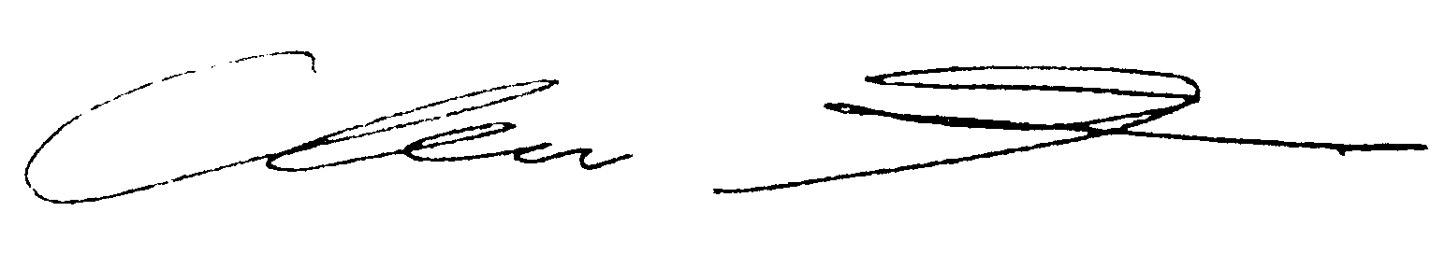
Aryan Gupta

